NETWORK DOCUMENTATION
Cisco Packet Tracer Lab: Connecting ACCOUNTS and DELIVERY Departments
Course: CCNA / Networking Fundamentals
Student Name: Anup kumar singh
Date: 01-12-2025

1. Objective
Design a network in Cisco Packet Tracer that connects the ACCOUNTS and DELIVERY departments.
The network must use the given network address 192.168.40.0 and ensure that:
✔ Each department has at least 2 PCs
✔ Proper number of switches and a router is used
✔ All devices are assigned correct IP address, subnet mask, and gateway
✔ Correct cabling
✔ Full connectivity between both departments (Ping must work)

2. Network Requirements (Based on Assignment)
a. Each department contains at least 2 PCs
b. Appropriate number of switches and one router must be used
c. Use network 192.168.40.0, configure IP, Subnet Mask, Gateway
d. Use correct cables (Straight-through)
e. Delivery PCs must ping Accounts PCs successfully

3. Subnetting
Given Network: 192.168.40.0/24
Since we need 2 departments → split into 2 subnets:

Subnet 1 – ACCOUNTS
- Network: 192.168.40.0/25
- Range: 192.168.40.1 – 192.168.40.126
- Gateway: 192.168.40.1
- Subnet Mask: 255.255.255.128

Subnet 2 – DELIVERY
- Network: 192.168.40.128/25
- Range: 192.168.40.129 – 192.168.40.254
- Gateway: 192.168.40.129
- Subnet Mask: 255.255.255.128
✔ Subnetting is correct
✔ Each department gets a separate /25 network

4. Network Topology Diagram
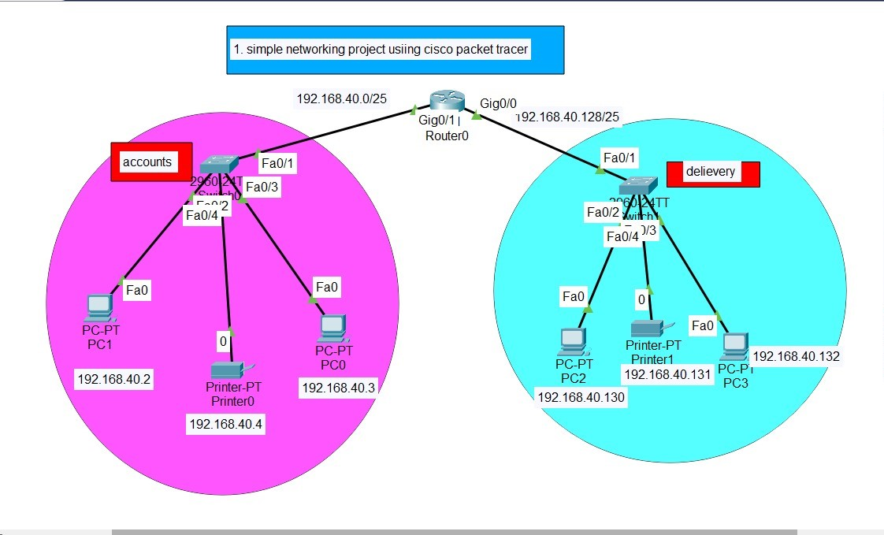

5. IP Addressing Table
Device | Interface | IP Address | Subnet Mask | Default Gateway
Router0 | G0/0 | 192.168.40.1 | 255.255.255.128 | -
Router0 | G0/1 | 192.168.40.129 | 255.255.255.128 | -
ACC PC0 | NIC | 192.168.40.3 | 255.255.255.128 | 192.168.40.1
ACC PC1 | NIC | 192.168.40.2 | 255.255.255.128 | 192.168.40.1
DEL PC2 | NIC | 192.168.40.130 | 255.255.255.128 | 192.168.40.129
DEL PC3 | NIC | 192.168.40.132 | 255.255.255.128 | 192.168.40.129

6. Device Configuration

Router Configuration
Router> enable
Router# configure terminal
Router(config)# hostname Router0

Router0(config)# interface gigabitEthernet0/0
Router0(config-if)# ip address 192.168.40.1 255.255.255.128
Router0(config-if)# no shutdown

Router0(config-if)# interface gigabitEthernet0/1
Router0(config-if)# ip address 192.168.40.129 255.255.255.128
Router0(config-if)# no shutdown

Router0# write memory

Switch Configuration (Basic)
Switch> enable
Switch# configure terminal
Switch(config)# hostname Switch-ACCOUNTS
Switch-ACCOUNTS(config)# exit
Switch-ACCOUNTS# write memory
Set ip -> subnet mask -> gateway
(All values taken from ip addressing table )

7. Cabling Summary
Connection | Cable Type
PC → Switch | Straight-through
Switch → Router | Straight-through
Switch ↔ Switch (if used) | Straight-through
(Packet Tracer supports auto-MDI/MDIX)

8. Connectivity Test (Ping Results)
From | To | Result
PC2 (Delivery) → PC0 (Accounts) | ✔ Success
PC3 (Delivery) → PC1 (Accounts) | ✔ Success
PC0 → PC2 | ✔ Success
PC1 → PC3 | ✔ Success
✔ All ping tests successful
✔ Both departments are fully connected
9. Conclusion
The network was successfully designed according to the assignment requirements:
✔ Proper subnetting using 192.168.40.0
✔ Correct IP addressing and gateways
✔ Correct router and switch configuration
✔ Correct cabling
✔ Full inter-department connectivity verified with ping

